REPUBLIKA HRVATSKA ZAVOD ZA JAVNO ZDRAVSTVO BRODSKO-POSAVSKA ŽUPANIJA BRODSKO-POSAVSKE ŽUPANIJE
ZAVOD ZA JAVNO ZDRAVSTVO BRODSKO-POSAVSKE ŽUPANIJE I ŽUPANIJA BRODSKO-POSAVSKA
organiziraju
ONE HEALTH SYMPOSIUM
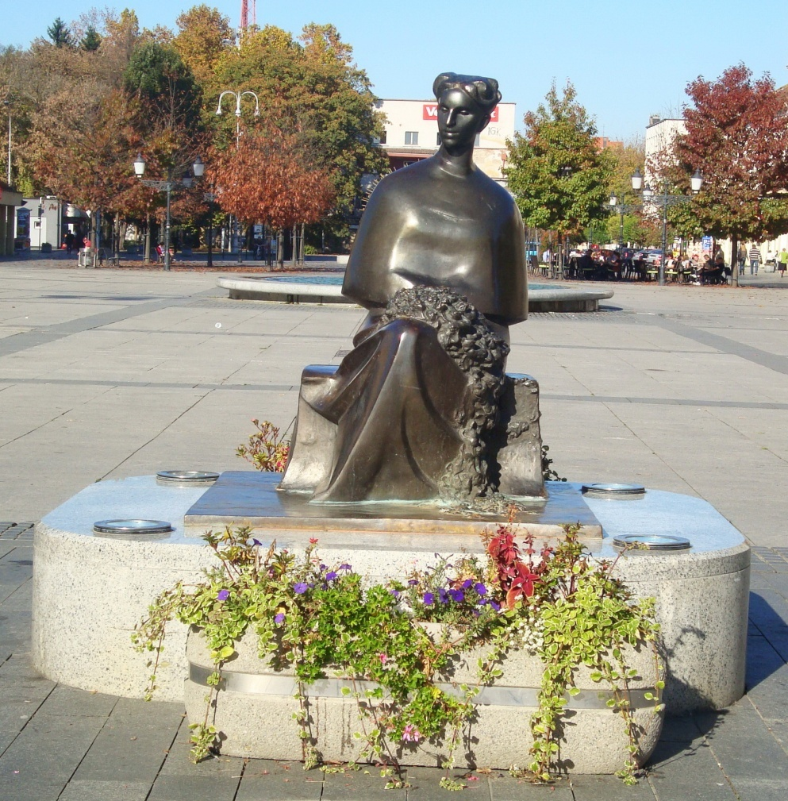
Slavonski Brod, 5. – 7- lipnja 2014.
ORGANIZACIJSKI ODBOR (abecednim redom): Ante Cvitković, Danijel Marušić, Zdenko Sonicki, John E. Vena
ZNANSTVENI ODBOR (abecednim redom): Carol P. Cotton, Ante Cvitković, Davor Ježek, Wilfried J. J. Karmaus, Dražen Matičić, Maja Miškulin, Tamara Poljičanin, Dinko Puntarić, Stephen L. Rathbun, Željko Reiner, Zdenko Sonicki, John E. Vena
POČASNI ODBOR (abecednim redom): Cathy A. Brown, Scott Brown, Irena Jurišić, Milan Milošević, Aida Mujkić, Maja Tomić Paradžik
TAJNICE: Molimo potvrditi dolazak na slijedeće e-mail adrese:
sandrapajkovic@gmail.com (Agencija SANDRA , tel: 0955128278)
martina.nadih@gmail.com (Zavod za javno zdravstvo Brodsko-posavske županije, tel: 0997315031)

MJESTO ODRŽAVANJA: Predavanja će se održati u Zavodu za javno zdravstvo Brodsko-posavske županije, A. Cesarca 71, dvorana, 1. kat
REGISTRACIJA I KOKTEL DOBRODOŠLICE je u četvrtak, 5. lipnja od 18-20 h u Zavodu za javno zdravstvo Brodsko-posavske županije, A. Cesarca 71
RADNI DIO SIMPOZIJA je u petak, 6. lipnja od 8.00 – 21.00 sati te u subotu, 7. lipnja od 8.00 – 15.00 sati
SMJEŠTAJ SUDIONIKA: Hoteli „Lotos“ i „Savus“ na Korzu, Trg Ivane Brlić Mažuranić; Hotel „Central“ u Ulici Petra Krešimira IV; Hotel „Art“ u Ulici Nikole Zrinskog 44 (rezervacije osobno)
KOTIZACIJA ZA SUDIONIKE: iznosi 500 kn uključuje koktel dobrodošlice, domjenak, ručak (petak i subota), svečanu večeru, zbornik radova; slobodan ulaz na predavanja
BROJ : IBAN HR 7224020061140205699, OIB: 84946680508
Simpozij će biti bodovan prema pravilniku Hrvatske liječničke komore.

TEME: PRIHVATLJIVE SU SVE TEME IZ JAVNOG ZDRAVSTVA I SRODNIH PODRUČJA KOJE SE UKLAPAJU U KONCEPT INICIJATIVE „ONE HEALTH“

PREDAVAČI (abecednim redom):
Cathy A. Brown, VMD, Ph. D., DACVP The University of Georgia, College of Veterinary Medicine
Scott Brown, VMD, Ph. D., DACVIM The University of Georgia, College of Veterinary Medicine
Carol P. Cotton, Ph.D., M. Ed. The University of Georgia, College of Public Health
Doc. prim. dr. sc. Ante Cvitković, dr. med. Zavod za javno zdravstvo Brodsko-posavske županije
Dr. sc. Fuštar Preradović Ljubica, dr. med. Opća bolnica „Dr. J. Benčević“, Slavonski Brod
Senka Gabud Gjurčević, dr. med. Zavod za javno zdravstvo Brodsko-posavske županije
Prof. dr. sc. Davor Ježek, dr. med. Medicinski fakultet u Zagrebu
Renata Josipović, mr. sc. Zavod za javno zdravstvo Brodsko-posavske županije
Irena Jurišić, dr. med. Zavod za javno zdravstvo Brodsko-posavske županije
Prof. Wilfried J. J. Karmaus, MD, Dr. Med., MPH The University of Memphis, School of Public Health
Danira Karzić, MPH The University of Georgia, College of Public Health
Prof. dr. sc. Josipa Kern Škola narodnog zdravlja „Dr. Andrija Štampar“, Medicinski fakultet u Zagrebu
Prof. dr. sc. Mirjana Kujundžić Tiljak, dr. med. Škola narodnog zdravlja „Dr. Andrija Štampar“, Medicinski fakultet u Zagrebu
Prof. dr. sc. Dražen Matičić, dr. vet. med. Veterinarski fakultet u Zagrebu
Doc. dr. sc. Ivo Matić, dr. med. Opća bolnica „Dr. J. Benčević“, Slavonski Brod
Dr.sc. Tomislav Meštrović, dr. med. Medicinski fakultet u Zagrebu
Dr. sc. Milan Milošević, dr. med. Škola narodnog zdravlja „Dr. Andrija Štampar“, Medicinski fakultet u Zagrebu
Prof. dr. sc. Maja Miškulin, dr. med. Medicinski fakultet u Osijeku
Prof. dr. sc. Aida Mujkić, dr. med. Škola narodnog zdravlja „Dr. Andrija Štampar“, Medicinski fakultet u Zagrebu
Dr. sc. Ivana Pajić Penavić, dr. med. Opća bolnica „Dr. J. Benčević“, Slavonski Brod
Dr. sc. Ivan Pećin, dr. med. Klinički bolnički centar Zagreb
Dr. sc. Tamara Poljičanin, dr. med. Hrvatski zavod za javno zdravstvo
Dr. sc. Zrinka Puharić, dr. med. Visoka tehnička škola, Bjelovar; Studij sestrinstva
Prof. dr. sc. Dinko Puntarić, dr. med. Medicinski fakultet u Osijeku
Prof. Stephen L. Rathbun, Ph.D. The University of Georgia, College of Public Health
Akademik Željko Reiner Klinički bolnički centar Zagreb, Medicinski fakultet u Zagrebu
Prim. Josip Samardžić, dr. med. Opća bolnica „Dr. J. Benčević“, Slavonski Brod
Prof. Barbara L. Schuster, MD, MACP Georgia Regents Universitiy & The University of Georgia
Prof. Richard J. Schuster, MD, MMM The University of Georgia, College of Public Health
Dr. sc. Jadranka Skurić, dr. med. Klinika za anesteziologiju, reanimatologiju i intenzivno liječenje, Klinička bolnica „Sveti duh“, Zagreb
Prof. dr. sc. Alen Slavica, dr. vet. med Veterinarski fakultet u Zagrebu
Prof. dr. sc. Zdenko Sonicki, dr. med Škola narodnog zdravlja „Dr. Andrija Štampar, Medicinski fakultet u Zagrebu
Prof. dr. sc. Hrvoje Tiljak, dr. med. Škola narodnog zdravlja „Dr. Andrija Štampar“, Medicinski fakultet u Zagrebu
Mr. sc. Maja Tomić Paradžik, dr. med. Zavod za javno zdravstvo Brodsko-posavske županije
Doc.dr. sc. Tatjana Šimurina, dr. med. Medicinski fakultet u Osijeku; Sveučilište u Zadru; Opća bolnica Zadar
Prof. John E. Vena, Ph. D. University of South Carolina, School of Public Health
Prof. emeritus, dr. sc. Silvije Vuletić, dr. med. Škola narodnog zdravlja „Dr. Andrija Štampar“, Medicinski fakultet u Zagrebu
Bethany Wolf, Ph. D. Assistant Professor of Biostatistics, Department of Public Health Sciences, Medical University of South Carolina

Četvrtak, 5. lipanj, 18.00 - 20.00
REGISTRACIJA I KOKTEL DOBRODOŠLICE
19.00-19.20 Puntarić D, Bošnir J, Jurak G, Puntarić I, Puntarić E: INFLUENCE OF TEMPERATURE, LENGTH OF STORAGE AND TECHNOLOGICAL FACTORS ON THE FORMATION OF N–NITROSAMINES IN MEAT PRODUCTS

Petak, 6. lipanj, 8.00 – 21.00

DVORANA A

8.00-8.20 Vena JE: THE PERILS OF THE HUNTER-GATHERER IN THE MODERN ERA 8.20-8.40 Vuletić S, Kern J: ONE HEALTH AND HEALTH NEEDS ASSESSMENT IN THE COMMUNITY
8.40-9.00 Schuster BL: DEVELOPING INTERDISCIPLINARY EDUCATIONAL OBJECTIVES IN ONE HEALTH
9.00-9.20 Schuster RJ: ONE HEALTH IN EMERGENCY PREPAREDNESS: A SYSTEMS NIGHTMARE
9.20-9.40 Ježek D: ENDOCRINE DISRUPTORS AND MALE INFERTILITY
9.40-10.00 Cotton CP: COLLABORATION AND CONTINUING INVESTMENT
10.00-10.20 Poljičanin T: STRATEŠKI PLAN RAZVOJA JAVNOG ZDRAVSTVA
20 min PAUZA

10.40-11.00 Karmaus WJJ: ENDEMIC NEPHROPATHY
11.00-11.20 Rathbun SL: BAYESIAN HIERARCHICAL MODELING FRAMEWORK FOR BALKAN ENDEMIC NEPHROPATHY
11.20-11.40 Sonicki Z: STATISTICAL MODELLING AND CASE-BASED REASONING – METHOD TO CAPTURE NEW EXPERIENCE
11.40-12.00 Fuštar Preradović Lj: THE ROLE OF CITOLOGY IN ENDEMIC NEPHROPATHY
12.00-12.20 Cvitković A: ENDEMIC NEPHROPATHY AND UPPER UROTHELIAL CARCINOMAS
12.20-12.40 Karzić D: SPATIAL ANALYSIS OF UPPER UROTHELIAL CARCINOMA CASES IN
THE ENDEMIC AREAS OF CROATIA
12.40-13.00 Wolf B, Spainhour C, Fleury T, Oates J: EVALUATION OF THE UTILITY OF RANDOM FOREST MODELS USING NOVEL BIOMARKER PANELS TO PREDICT MEDIUM TERM TREATMENT SUCCESS IN LUPUS NEPHRITIS
13.00-13.20 Milošević M: IS SEVEN MINUTES ENOUGH? DIFFERENT APPROACHES TO 1:00 PROGRAMMED AND POPULATION TARGETED PHYSICAL ACTIVITY

1 sat RUČAK

14.20-14.40 Wolf B, Slate E: GRAPHICAL TOOLS FOR LOGIC ENSEMBLES: EXPLORING INTERACTIONS AMONG GENETIC AND HEALTH FACTORS FOR PREDICTING DISEASE
14.40-15.00 Matić I, Pajić-Penavić I, Bašić M, Jurjević M: AIRWAY MANAGEMENT IN OUT- OF HOSPITAL PATIENTS WITH CARDIAC ARREST
15.00-15.20 Samardžić J: IS LAPAROSCOPY A NEW SURGICAL CORNERSTONE
15.20-15.40 Skurić J, Stanić G: ANIMAL RESEARCH IN ANAESTHESIOLOGY
15.40-16.00 Meštrović T: PREDICTION OF OPERATIVE MORTALITY IN VASCULAR SURGERY - USING DATA MINING METHODS
16.00-16.20 Puharić Z: 4 D PROBLEMS OF SCHOOL CHILDREN
16.20-16.40 Pajić-Penavić I, Matić I, Pandak N, Jurjević M, Sauerborn D: HYPOVITAMINOSIS OF VITAMIN D IN PATIENT WITH CHRONIC UPPER RESPIRATORY DISEASE
16.40-17.00 Šimurina T: PREDICTION OF NAUSEA AND VOMITING AFTER SURGERY UNDER GENERAL ANESTHESIA: PRESENT AND FUTURE
17.00-19.00 OKRUGLI STOL
19.00-21.00 VEČERA
DVORANA B

14.30-15.30 RADIONICA : Endemic nephropathy and upper urothelial carcinomas
15.30-16.30 RADIONICA: Public/environmental health

SUBOTA, 7. lipanj, 8.00 - 15.00
DVORANA A
8.00-8.20 Brown CA: OUTBREAKS OF RENAL DISEASE IN DOGS AND CATS DUE TO CONTAMINATED PET FOODS
8.20-8.40 Brown AS: LESSONS LEARNED FROM OUTBREAKS OF RENAL DISEASE IN DOGS AND CATS DUE TO CONTAMINATED PET FOODS
8.40-9.00 Slavica A, Barbić LJ, Konjević D: EMERGING ZOONOSES IN WIDLIFE
9.00-9.20 Matičić D: METHICILLIN-RESISTANT STAPHYLOCOCCUS AUREUS (MRSA) AND COMPANION ANIMALS – A ONE HEALTH PERSPECTIVE
9.20-9.40 Reiner Ž, Pećin I: NO BORDERS FOR RARE DISORDERS
9.40-10.00 Mujkić A, Gereš N, Miškulin M, Meštrović J: COMPARISON BETWEEN THE EUROPEAN UNION AND CROATIA REGARDING CHILD INJURIES FATALITIES
10.00-10.20 Kujundžić Tiljak M: MORTALITY RATES ADJUSTMENT DUE TO THE
GENEALOGICAL STRUCTURE OF A POPULATION
20 min PAUZA
10.40-11.00 Tiljak H, Sović S: METHODOLOGICAL ISSUES IN OBSERVING FAMILY
PRACTITIONERS TASK PROFILE
11.00-11.20 Miškulin M, Mujkić A, Miškulin I: HARMFUL FACTORS IN THE WORK ENVIRONMENT AND SICK BUILDING SYNDROME
11.20-11.40 Jurišić I: SYNTHETIC DRUGS - A PUBLIC HEALTH PROBLEM
11.40-12.00 Tomić Paradžik M: SURVEILLANCE OF ANTIMICROBIAL RESISTANCE
12.00-12.10 Josipović R, Cvitković A, Nadih M, Medverec-Knežević Z, Mrvčić J, Markov K, Frece J, Delaš F, Stanzer D: NUTRITIVE VALUE AND QUALITY OF CHEESE WITH DIFFERENT SPICES
12.10-12.20 Senka Gabud Gjurčević : THE IMPORTANCE AND ROLE OF FAMILY SUPPORT IN PREVENTION OF ADDICTION
DVORANA B
9.00-10.00 RADIONICA: International collaboration
1 sat RUČAK
12.20-15.00 RADIONICA I ZAKLJUČCI

